|  |
| --- |
| Circle Language Spec: Events |

## Event Situations

Several situations are possible in case of events. Events are *multi-cast*, meaning that multiple commands in multiple objects can run in response to the event. Also, a child object is not the only object you can pick up events from. You can also pick up events from deeper objects.

### Multi-Cast Events

An event can be picked up by multiple parent objects when they both have a reference to the event-casting object and they both define an event command:

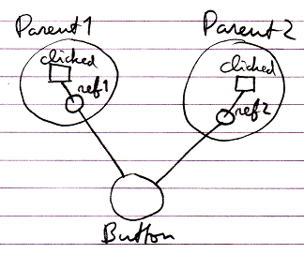

### Multi-Cast in Same Parent

Multiple commands can be bound to an event, even when they both are defined inside the same parent object:

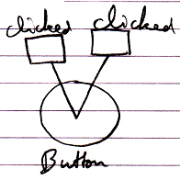

### Event with Parameters

Events can have parameters. Here is an example of an event with a parameter.

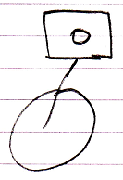

### Event From Deeper Object

A child object is not the only object you can pick up events from. You can just as easily pick up events from a deeper object.

